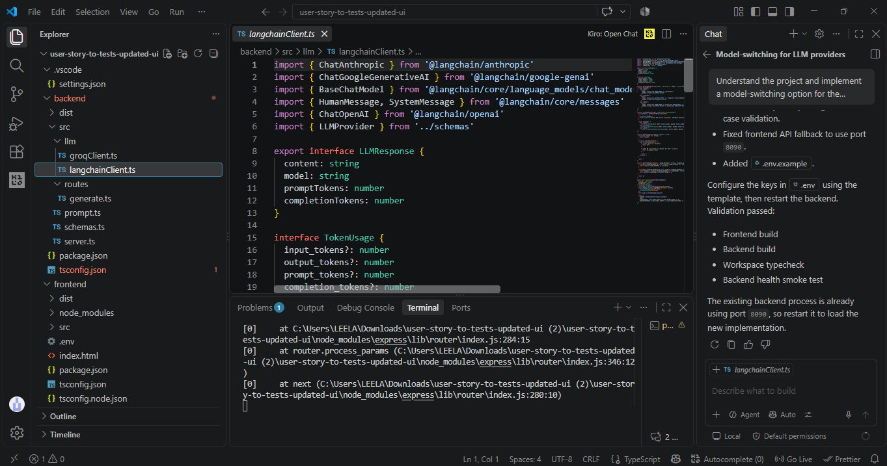

import { ChatAnthropic } from '@langchain/anthropic'
import { ChatGoogleGenerativeAI } from '@langchain/google-genai'
import { BaseChatModel } from '@langchain/core/language_models/chat_models'
import { HumanMessage, SystemMessage } from '@langchain/core/messages'
import { ChatOpenAI } from '@langchain/openai'
import { LLMProvider } from '../schemas'

export interface LLMResponse {
content: string
model: string
promptTokens: number
completionTokens: number
}

interface TokenUsage {
input_tokens?: number
output_tokens?: number
prompt_tokens?: number
completion_tokens?: number
}

function getProviderDetails(provider: LLMProvider): { model: string; apiKey?: string } {
switch (provider) {
case 'openai':
return {
model: process.env.OPENAI_MODEL || 'gpt-4o-mini',
apiKey: process.env.OPENAI_API_KEY
}
case 'anthropic':
return {
model: process.env.ANTHROPIC_MODEL || 'claude-3-5-sonnet-20241022',
apiKey: process.env.ANTHROPIC_API_KEY
}
case 'gemini':
return {
model: process.env.GEMINI_MODEL || process.env.GOOGLE_MODEL || 'gemini-2.0-flash',
apiKey: process.env.GEMINI_API_KEY || process.env.GOOGLE_API_KEY
}
}
}

function createModel(provider: LLMProvider): BaseChatModel {
const details = getProviderDetails(provider)

if (!details.apiKey) {
throw new Error(`Missing API key for ${provider}. Configure the provider key in the backend environment.`)
}

switch (provider) {
case 'openai':
return new ChatOpenAI({ model: details.model, apiKey: details.apiKey, temperature: 0.2 })
case 'anthropic':
return new ChatAnthropic({ model: details.model, apiKey: details.apiKey, temperature: 0.2 })
case 'gemini':
return new ChatGoogleGenerativeAI({ model: details.model, apiKey: details.apiKey, temperature: 0.2 })
}
}

function getTextContent(content: unknown): string {
if (typeof content === 'string') {
return content
}

if (Array.isArray(content)) {
return content.map((part) => {
if (typeof part === 'string') {
return part
}

if (part && typeof part === 'object' && 'text' in part) {
return String(part.text)
}

return ''
}).join('')
}

return ''
}

function getTokenUsage(response: { usage_metadata?: unknown; response_metadata?: unknown }): TokenUsage {
if (response.usage_metadata && typeof response.usage_metadata === 'object') {
return response.usage_metadata as TokenUsage
}

if (response.response_metadata && typeof response.response_metadata === 'object') {
const metadata = response.response_metadata as { tokenUsage?: TokenUsage; usage?: TokenUsage }
return metadata.tokenUsage || metadata.usage || {}
}

return {}
}

export async function generateWithLangChain(
provider: LLMProvider,
systemPrompt: string,
userPrompt: string
): Promise<LLMResponse> {
const model = getProviderDetails(provider).model
const response = await createModel(provider).invoke([
new SystemMessage(systemPrompt),
new HumanMessage(userPrompt)
])
const usage = getTokenUsage(response)

return {
content: getTextContent(response.content),
model,
promptTokens: usage.input_tokens || usage.prompt_tokens || 0,
completionTokens: usage.output_tokens || usage.completion_tokens || 0
}
}

